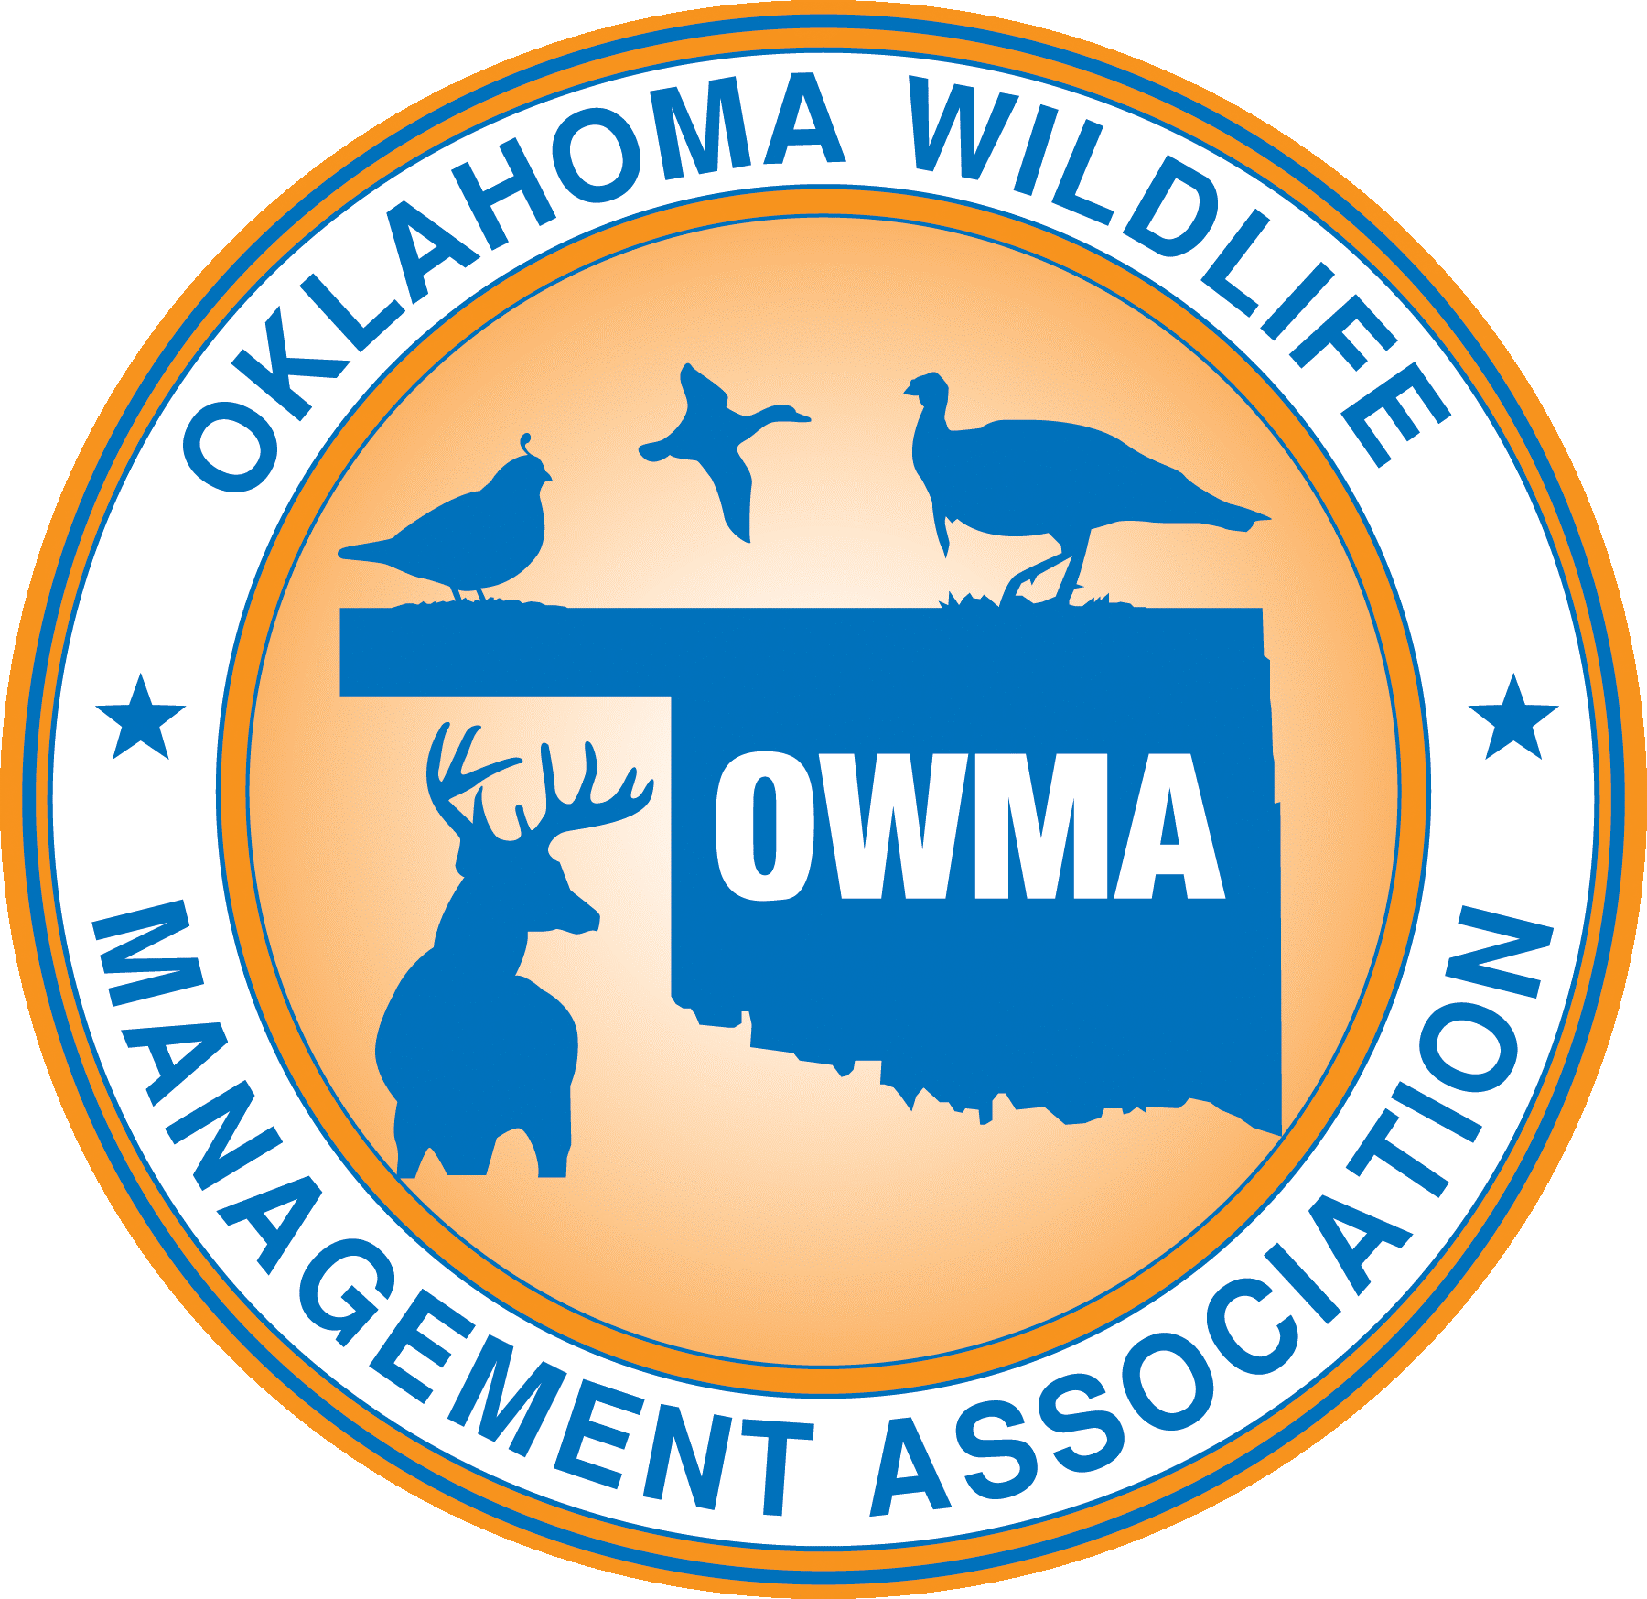
OWMA
743 County Road 1350
Chickasha, OK. 73018-8018
405-820-0885
OWMA.OWMF@gmail.com

Wild Game Legislative Registration Form:

Name: _____________________________________________________

Address: __________________________________________________

City/State/Zip: ______________________________________________

Email: _____________________________________________________

Contact Phone Number: ______________________________________

You may pay one of three ways:
- PayPal via our website at: https://www.ok-wildlife.com
- You can send a check to: OWMA
743 County Road 1350
Chickasha, OK. 73018-8018
- You may pay via credit card at the event OR email the following information from your credit card: Name (as it appears on card)/Account Number/Expiration Date

