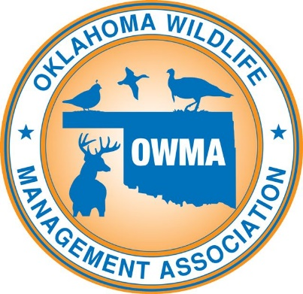

Oklahoma Wildlife Management Association
2019 OWMA Sporting Clay Shoot
Saturday, June 15, 2019

Gold Sponsor - $1,000 cash donation:
- Company recognition at the event and on the OWMA website and Facebook page
- Entry of two, 4-man sporting clay teams.
- 8 individual OWMA memberships

Silver Sponsor - $500 cash donation:
- Company recognition at the event and on the OWMA website and Facebook page
- Entry of one, 4-man sporting clay team
- 4 individual OWMA memberships

Youth or Law Enforcement Team Sponsor - $500 cash donation:
- Company recognition at the event and on the OWMA website and Facebook page
- Sponsorship used to pay entry fee for members of the local law enforcement or
youth teams from local 4-H or FFA chapters

Prize Sponsor - $400 or less cash donation or prize donation:
- Company recognition at the event and on the OWMA website and Facebook page

Sponsorship checks can be mailed to:

OWMA
743 County Road 1350
Chickasha, OK 73018-8018

